CS 542 – Computer Networks I: Fundamentals Fall 2023 HW1 (108 points)

***Submission instructions***

## Due date: Sunday, Oct. 29, 11:59 pm Central Time

* ***Late submissions and submissions violating these instructions will NOT be accepted.***
* ***No handwritten submissions. No credit will be given for the handwritten submissions.***
* ***Teamwork is allowed (max. 4 students/team). Individual submissions are also OK.***
* ***Upload your HW (pdf format only) to Blackboard. Submissions in formats other than pdf will be disregarded. The Beacon students: upload your submissions to Lumina.***
* ***One submission per team only. Write down names, A#, and section numbers of all the team members on the front page. Do not submit multiple copies of your HW (e.g. by each team member). It is very confusing and will be penalized. Clearly indicate how each team member contributed to your teamwork.***
* ***Show your work and explain every step of your solution for full credit. Only partial credit will be given for a correct final answer with missing calculations, no supporting explanations or unclear justifications.***
* ***My TAs Pranav Saji (psaji@hawk.iit.edu) and Aditya Sai Kolluru (akolluru@hawk.iit.edu) are responsible for grading this HW assignment. Feel free to ask questions is something is not clear***

***but don't send me or my TAs:***

* ***Your partial solutions with inquiries “Is that what you expect?”.***
* ***Questions, the answers to, may give explicit hints on how to solve the HW problems.***

1. Please give and explain your answers to the questions below. **(5 points)**
   1. What is the range of addresses of the 64th block of Class A? **(1 point)**
   2. Consider fixed-length subnetting. What is the maximum number of created subnets if the desired number of subnets is: **(4 points)**
      1. 2
      2. 62

c. 122

d. 250

1. A network administrator uses the subnet mask 255.255.252.0 in the network 191.168.0.0. How many total subnets have been created, and what's the size of each subnet? Assume classful addressing. **(3 points)**
2. If you subnet the network 10.0.0.0 with a subnet mask of 255.255.240.0, what's the maximum number of subnets and hosts per subnet? Assume classful addressing. **(3 points)**
3. A network 10.5.6.0/24 is subnetted with a mask of 255.255.255.192. How many subnets are created and what is the third subnet's last usable IP address? **(4 points)**
4. An ISP has the block 192.100.0.0/16 and wants to allocate subblocks to organizations, each with 500 IP addresses. How many subblocks can be provided and what is their mask? **(4 points)**
5. Find the network address, the direct broadcast address, and the number of addresses in the network, if one of the addresses is 183.70.230.23/20. **(4 points)**
6. Divide the network 126.168.24.0/24 into 4 subnets. What is the subnet mask? Give the range of IP addresses for each subnet. Which of these addresses can not be assigned to hosts?**(5 points)**
7. Can the following IP addresses be assigned to a host? Explain your answers. **(6 points)**

a. 255.255.255.255 **(1 point)**

b. 127.32.45.0 **(1 point)**

* + 1. 43.0.0.0 (assume classless addressing; note that the mask is not given) **(2 points)**
    2. 1.64.126.32 (assume classless addressing; note that the mask is not given) **(2 points)**

1. The block 172.16.0.0/16 is given. Create 3 subnets with the number of hosts given below. Find the subnet addresses and the subnet masks for each subnet. **(6 points)**
   1. 1st subnet: 2000 hosts
   2. 2nd subnet: 500 hosts
   3. 3rd subnet: 100 hosts
2. An ISP is allocated the block 128.45.32.0/24. This ISP needs to assign 16 addresses per customer. Find the mask for each of these subnets and give the first and last usable IP addresses for the first three subnets. **(4 points)**
3. A certain company wants to create two subnets to meet its network requirements. Find the suffix and prefix lengths for these subnets, one with 67 addresses and the other with 34 addresses. **(3 points)**
4. The block of addresses 146.157.224.0/19 is divided into 3 subblocks. The 1st subblock is allocated to a group of 12 customers, each of which needs 64 addresses. The 2nd subblock is allocated to a group of 9 customers, each of which needs 32 addresses. The 3rd subblock is allocated to a group of 5 customers, each of which needs 16 addresses. **(16 points)**
   1. Design the three subblock. Find the mask for each of them (i.e. for each subblock not for each customer). **(6 points)**
   2. What is the range of addresses (find the first and last of them) allocated to the 10th customer in the 1st subblock? **(2 points)**
   3. What is the range of addresses (find the first and last of them) allocated to the 5th customer in the 2nd subblock? **(2 points)**
   4. What is the range of addresses (find the first and last of them) allocated to the 3rd customer in the 3rd subblock? **(2 points)**
   5. How many addresses are still available after this allocation in each of the three subblocks?

# (3 points)

* 1. How many addresses are still available after this allocation in the entire original block?

# (1 point)

1. Is the delivery direct or indirect? **(4 points)**
   1. A host with the IP address 131.16.192.4/16 sends a packet to a host with the IP address 132.16.128.19/18. Explain your answer.

Ans:

Here,

We need to first compare the sender and receiver’s network addresses and subnet masks to determine if the packet was delivered directly or indirectly.

* **Sender’s IP address:** 131.16.192.4/16
* **Receiver’s IP address:** 132.16.128.19/18

The subnet masks (/16 and /18) in both scenarios indicate that the network address is represented by the first 16 bits and first 18 bits respectively. Now, let's compare the network addresses:

* **Sender’s Network Address:** 131.16.0.0/16 (First 16 bits are fixed)
* **Receiver’s Network Address:** 132.16.128.0/18 (First 18 bits are fixed)

The sender and the recipient are on separate subnets since the first 16 bits of the address provided by the sender (131.16) do not match the first 18 bits of the receiver's address (132.16.128). This indicates that a direct delivery of the packet within the local network is not possible.

As a result, the packet would be delivered indirectly from the host with IP address 131.16.192.4/16 to the host with IP address 132.16.128.19/18. To get to the destination subnet, the packet must be routed via routers and other networking devices.

**Therefore, this is an indirect delivery.**

* 1. A host with the IP address 87.136.56.126/25 sends a packet to a host with the IP address 87.136.56.111/25. Explain your answer.

Ans:

Here,

We need to first compare the sender and receiver’s network addresses and subnet masks to determine if the packet was delivered directly or indirectly.

* **Sender’s IP address:** 87.136.56.126/25
* **Receiver’s IP address:** 87.136.56.111/25

The subnet masks (/25 and /25) in both scenarios indicate that the network address is represented by the first 25 bits for both the addresses respectively. Now, let's compare the network addresses:

* **Sender’s Network Address:** 87.136.56.0/25 (First 25 bits are fixed)
* **Receiver’s Network Address:** 87.136.56.0/25 (First 25 bits are fixed)

As we can see both the sender’s and receiver’s network address matches. The packet would be delivered directly from the host having IP address 87.136.56.126/25 to the host having IP address 87.136.56.111/25 since both the sender and the receiver have IP addresses that are within the same subnet (87.136.56.0/25). Since they are connected to the same local network, there is no need for the devices to communicate with one another via intermediary networks or devices.

**Therefore, this is a direct delivery.**

1. Why do we need both the IP addresses and the physical addresses in networking? **(3 points)**

**Ans:**

Both physical addresses and IP addresses have different functions in computer networking and are essential for a network to operate properly.

* **Why we need IP addresses:**

1. **Logical Addressing:**

Devices on the network are uniquely identified by their IP addresses. And for communication via the internet to be made possible, each device that is linked to a network needs to have its own IP address.

1. **Routing:**

Data packets need IP addresses in order to be routed between networks. IP addresses are used by routers to identify a packet's subsequent hop on its path to the target network.

* **Why we need physical addresses:**

1. **Hardware Communication at a Low Level:**

Within a network segment, MAC (Media Access Control) addresses are used for local identification. The manufacturer applies a unique MAC address onto each network interface card (NIC) of a device.

1. **Data Link Layer Communication:**

Devices connected to the exact same physical network utilize MAC addresses to speak with one another directly. Devices on the same local network sends information to the data link layer using their MAC addresses to interact with each other.

* **Why we need both?**

1. **Routing and Forwarding:**

In order for router to route packets between networks, they require IP addresses. IP addresses are used by routers to decide where to deliver data. The MAC address is utilized for the final transmission of the data to the designated device inside the network after it has reached the relevant local network.

1. **Hierarchical Addressing:**

IP addresses offer a hierarchical addressing method that facilitates effective routing over vast networks, such as the internet. MAC addresses are only used to interact between a local network segment and lack this hierarchical structure.

In conclusion, MAC addresses is required because they are used to provide physical, local identity for devices within the exact same network segment and provide direct communication at the data link layer and IP addresses are needed because they are used to provide logical, global identification and ease routing between other networks. Computer networks cannot operate effectively or dependably without both addresses.

1. For the routing tables given below, draw the network configuration including all the 4 routers (i.e. not each router separately). Indicate the next-hop addresses in the figure. **(12 points)**

R1:

|  |  |  |  |
| --- | --- | --- | --- |
| Mask | Network Address | Next-Hop Address | Interface Number |
| /24 | 223.153.9.0 | ----------- | M0 |
| /24 | 200.156.72.0 | ----------- | M1 |
| /16 | 191.194.0.0 | 12.0.213.12 | M2 |
| /16 | 135.65.0.0 | 223.153.9.126 | M0 |
| /16 | 128.98.0.0 | 12.0.213.12 | M2 |
| /8 | 12.0.0.0 | ----------- | M2 |
| /8 | 126.0.0.0 | 223.153.9.126 | M0 |
| Default | Default | unspecified | M3 |

R2:

|  |  |  |  |
| --- | --- | --- | --- |
| Mask | Network Address | Next-Hop Address | Interface Number |
| /16 | 191.194.0.0 | ----------- | M0 |
| /16 | 128.98.0.0 | ----------- | M1 |
| /8 | 12.0.0.0 | ----------- | M2 |
| Default | Default | 12.163.31.4 | M2 |

R3:

|  |  |  |  |
| --- | --- | --- | --- |
| Mask | Network Address | Next-Hop Address | Interface Number |
| /16 | 135.65.0.0 | ----------- | M0 |
| /8 | 126.0.0.0 | ----------- | M1 |
| Default | Default | 135.65.13.6 | M0 |

R4:

|  |  |  |  |
| --- | --- | --- | --- |
| Mask | Network Address | Next-Hop Address | Interface Number |
| /24 | 223.153.9.0 | ----------- | M0 |
| /16 | 135.65.0.0 | ----------- | M1 |
| /8 | 126.0.0.0 | 135.65.172.11 | M1 |
| Default | Default | 223.153.9.1 | M0 |

1. Consider the network configuration given below. Assume classful addressing. **(14 points)**
   1. Are there any errors in this figure? If so, correct them. **(2 points)**
   2. Create a routing table for each router given in this figure. Indicate class, network address, next-hop address and interface number in each routing table. **(12 points)**

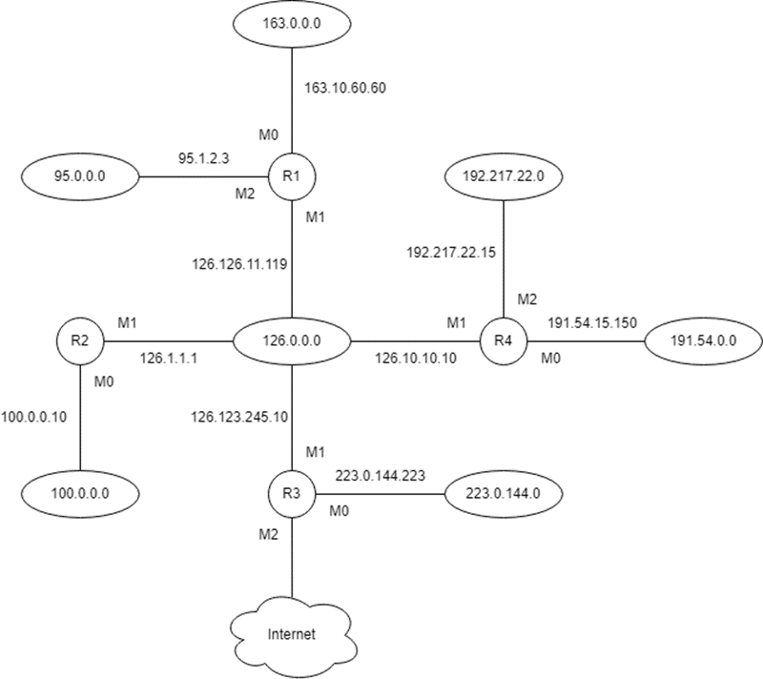`

1. Consider the network configuration given above in Question 16. Assume classful addressing. Explain how the following packets are routed in this network (consider the entire network, not a single router). **(6 points)**
2. Host 100.235.37.18 sends a packet to destination 191.54.17.05
3. Host 192.217.22.173 sends a packet to destination 223.0.144.2
4. Host 95.12.234.7 sends a packet to destination 127.201.165.11
5. Convert the hexadecimal IP address 0xC0A801A2 to the dotted decimal and binary notations. Determine the class of this address in each of these notations. **(4 points)**

**Ans:**

Given,

Hexadecimal IP address = 0xC0A801A2

In the hexadecimal numbering system, two digits are used to represent one byte, or eight bits in the dotted decimal numbering system.

|  |  |  |  |  |  |
| --- | --- | --- | --- | --- | --- |
| **Decimal** | **Binary** | **Hexadecimal** | **Decimal** | **Binary** | **Hexadecimal** |
| 0 | 0000 | 0 | 8 | 1000 | 8 |
| 1 | 0001 | 1 | 9 | 1001 | 9 |
| 2 | 0010 | 2 | 10 | 1010 | **A** |
| 3 | 0011 | 3 | 11 | 1011 | **B** |
| 4 | 0100 | 4 | 12 | 1100 | **C** |
| 5 | 0101 | 5 | 13 | 1101 | **D** |
| 6 | 0110 | 6 | 14 | 1110 | **E** |
| 7 | 0111 | 7 | 15 | 1111 | **F** |

|  |  |  |  |  |
| --- | --- | --- | --- | --- |
| **Given Address** | C0 | A8 | 01 | A2 |
| **Equivalent Binary Format** | 11000000 | 10101000 | 00000001 | 10100010 |

|  |  |  |  |  |  |  |  |  |  |
| --- | --- | --- | --- | --- | --- | --- | --- | --- | --- |
| **Place Value** | **2^7** | **2^6** | **2^5** | **2^4** | **2^3** | **2^2** | **2^1** | **2^0** | **Place value in Decimal** |
| **1st Byte** | 1 | 1 | 0 | 0 | 0 | 0 | 0 | 0 | 192 |
| **2nd Byte** | 1 | 0 | 1 | 0 | 1 | 0 | 0 | 0 | 168 |
| **3rd Byte** | 0 | 0 | 0 | 0 | 0 | 0 | 0 | 1 | 1 |
| **4th Byte** | 1 | 0 | 1 | 0 | 0 | 0 | 1 | 0 | 162 |

**The address in dotted decimal format is:** 192.168.1.162

**The address in binary format is:** 11000000 10101000 00000001 10100010

**The class of this address is Class C**. Class C ranges from 192.0.0.0 to 223.255.255.255

1. Convert the decimal number 218892292 to the base 256 numbering system. **(2 points)**

**Ans:**

Given,

Decimal number = 218892292

We need to constantly divide the decimal number 218892292 by 256 while keeping the track of the remainders in order to convert it to the base 256 numbering system. The conversion is carried out as follows:

* 218892292 ÷ 256 = 855048 with a remainder of 4
* 854675 ÷ 256 = 3340 with a remainder of 8
* 3333 ÷ 256 = 13 with a remainder of 12
* 13 ÷ 256 = 0 with a remainder of 13

Then we need to read the remainders from bottom to top. So, 218892292’s base 256 representation is 13.12.8.4 in the base 256 numbering system.

**The decimal number = 218892292**

**The base 256 numbering system = 13.12.8.4**